SAVITRIBAI PHULE PUNE UNIVERSITY

A PRELIMINARY PROJECT REPORT ON

LEARNING APP FOR KIDS

SUBMITTED TOWARDS THE

PARTIAL FULFILLMENT OF THE REQUIREMENTS OF

BACHELOR OF ENGINEERING (Computer Engineering)

BY

SALIL GAUTAM

Exam No:S150224245

NAVNEET SINGH

Exam No: S150224206

SAURABH SINGH

Exam No: S150224247

Under The Guidance of

Prof. A.P. Kadam



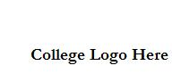

DEPARTMENT OF COMPUTER ENGINEERING

ARMY INSTITUTE OF TECHNOLOGY
DIGHI HILLS, PUNE- 411015.

CERTIFICATE

This is to certify that the Project Entitled

LEARNING APP FOR KIDS

Submitted by

SALIL GAUTAM

Exam No:S150224245

NAVNEET SINGH

Exam No: S1502242

SAURABH SINGH

Exam No: S150224247

is a bonafide work carried out by Students under the supervision of Prof. Guide

Name and it is submitted towards the partial fulfillment of the requirement of Bach-

elor of Engineering (Computer Engineering) Project.

Prof. A.P. KADAM | Prof. P.DHORE
Internal Guide | H.O.D
Dept. of Computer Engg. | Dept. of Computer Engg.

Abstract

Please Write here One Page Abstract. It should mainly include introduction, moti-vation,outcome and innovation if any.

AIT, Department of Computer Engineering 2017-2018 I

Acknowledgments

It gives us great pleasure in presenting the preliminary project report on

‘Learning APP FOR KIDS’

I would like to take this opportunity to thank my internal guide Prof. A.P.KADAM for giving me all the help and guidance I needed. I am really grateful to them for their kind support. Their valuable suggestions were very helpful.

I am also grateful to Prof. PD DHORE, Head of Computer Engineering Department, ARMY INSTITIUTE OF TECHNOLOGY for his indispensable support, suggestions.

In the end our special thanks to Other Person Name for providing various resources such as laboratory with all needed software platforms, continuous Internet connection, for Our Project.

SALIL GAUTAM

NAVNEET SINGH

SAURABH SINGH

(B.E. Computer Engg.)

INDEX

1 | Synopsis |  | 1
 | 1.1 | Project Title . . . . . . . . . . . . . . . . . . . . . . . . . . . . . . | 2
 | 1.2 | Project Option . . . . . . . . . . . . . . . . . . . . . . . . . . . . | 2
 | 1.3 | Internal Guide . . . . . . . . . . . . . . . . . . . . . . . . . . . . . | 2
 | 1.4 | Sponsorship and External Guide . . . . . . . . . . . . . . . . . . . | 2
 | 1.5 | Technical Keywords (As per ACM Keywords) . . . . . . . . . . . . | 2
 | 1.6 | Problem Statement . . . . . . . . . . . . . . . . . . . . . . . . . . | 2
 | 1.7 | Abstract . . . . . . . . . . . . . . . . . . . . . . . . . . . . . . . . | 3
 | 1.8 | Goals and Objectives . . . . . . . . . . . . . . . . . . . . . . . . . | 3
 | 1.9 | Relevant mathematics associated with the Project . . . . . . . . . . | 3
 | 1.10 | Names of Conferences / Journals where papers can be published . . | 3
 | 1.11 | Review of Conference/Journal Papers supporting Project idea . . . . | 4
 | 1.12 | Plan of Project Execution . . . . . . . . . . . . . . . . . . . . . . . | 4
2 | Technical Keywords |  | 5
 | 2.1 | Area of Project . . . . . . . . . . . . . . . . . . . . . . . . . . . . | 6
 | 2.2 | Technical Keywords . . . . . . . . . . . . . . . . . . . . . . . . . . | 6
3 | Introduction |  | 7
 | 3.1 | Project Idea . . . . . . . . . . . . . . . . . . . . . . . . . . . . . . | 8
 | 3.2 | Motivation of the Project . . . . . . . . . . . . . . . . . . . . . . . | 8
 | 3.3 | Literature Survey . . . . . . . . . . . . . . . . . . . . . . . . . . . | 8
4 Problem Definition and scope |  |  | 9
 | 4.1 | Problem Statement . . . . . . . . . . . . . . . . . . . . . . . . . . | 10

 | 4.1.1 | Goals and objectives . . . . . . . . . . . . . . . . . . . . . | 10
 | 4.1.2 | Statement of scope . . . . . . . . . . . . . . . . . . . . . . | 10
4.2 | Software context . . . . . . . . . . . . . . . . . . . . . . . . . . . |  | 10
4.3 | Major Constraints . . . . . . . . . . . . . . . . . . . . . . . . . . . |  | 10
4.4 | Methodologies of Problem solving and efficiency issues . . . . . . . |  | 10
4.5 | Scenario in which multi-core, Embedded and Distributed Computing
 | used . . . . . . . . . . . . . . . . . . . . . . . . . . . . . . . . . . |  | 11
4.6 | Outcome . . . . . . . . . . . . . . . . . . . . . . . . . . . . . . . . |  | 11
4.7 | Applications . . . . . . . . . . . . . . . . . . . . . . . . . . . . . . |  | 11
4.8 | Hardware Resources Required . . . . . . . . . . . . . . . . . . . . |  | 11
4.9 | Software Resources Required . . . . . . . . . . . . . . . . . . . . . |  | 11
5 Project Plan |  |  | 12
5.1 | Project Estimates . . . . . . . . . . . . . . . . . . . . . . . . . . . |  | 13
 | 5.1.1 | Reconciled Estimates . . . . . . . . . . . . . . . . . . . . . | 13
 | 5.1.2 | Project Resources . . . . . . . . . . . . . . . . . . . . . . . | 13
5.2 | Risk Management w.r.t. NP Hard analysis . . . . . . . . . . . . . . |  | 13
 | 5.2.1 | Risk Identification . . . . . . . . . . . . . . . . . . . . . . | 13
 | 5.2.2 | Risk Analysis . . . . . . . . . . . . . . . . . . . . . . . . . | 14
 | 5.2.3 | Overview of Risk Mitigation, Monitoring, Management . . | 15
5.3 | Project Schedule . . . . . . . . . . . . . . . . . . . . . . . . . . . |  | 15
 | 5.3.1 | Project task set . . . . . . . . . . . . . . . . . . . . . . . . | 15
 | 5.3.2 | Task network . . . . . . . . . . . . . . . . . . . . . . . . . | 16
 | 5.3.3 | Timeline Chart . . . . . . . . . . . . . . . . . . . . . . . . | 16
5.4 | Team Organization . . . . . . . . . . . . . . . . . . . . . . . . . . |  | 16
 | 5.4.1 | Team structure . . . . . . . . . . . . . . . . . . . . . . . . | 16
 | 5.4.2 | Management reporting and communication . . . . . . . . . | 16

6 Software requirement specification (SRS is to be prepared using relevant mathematics derived and software engg. Indicators in Annex A and B) 17 6.1 Introduction . . . . . . . . . . . . . . . . . . . . . . . . . . . . . . 18

6.1.1 Purpose and Scope of Document . . . . . . . . . . . . . . . 18

AIT, Department of Computer Engineering 2017-2018 I
IV

 |  | 6.1.2 | Overview of responsibilities of Developer . . . . . . . . . . | 18
 | 6.2 | Usage Scenario . . . . . . . . . . . . . . . . . . . . . . . . . . . . |  | 18
 |  | 6.2.1 | User profiles . . . . . . . . . . . . . . . . . . . . . . . . . | 18
 |  | 6.2.2 | Use-cases . . . . . . . . . . . . . . . . . . . . . . . . . . . | 18
 |  | 6.2.3 | Use Case View . . . . . . . . . . . . . . . . . . . . . . . . | 18
 | 6.3 | Data Model and Description . . . . . . . . . . . . . . . . . . . . . |  | 19
 |  | 6.3.1 | Data Description . . . . . . . . . . . . . . . . . . . . . . . | 19
 |  | 6.3.2 | Data objects and Relationships . . . . . . . . . . . . . . . . | 19
 | 6.4 | Functional Model and Description . . . . . . . . . . . . . . . . . . |  | 19
 |  | 6.4.1 | Data Flow Diagram . . . . . . . . . . . . . . . . . . . . . . | 20
 |  | 6.4.2 | Description of functions . . . . . . . . . . . . . . . . . . . | 20
 |  | 6.4.3 | Activity Diagram: . . . . . . . . . . . . . . . . . . . . . . | 21
 |  | 6.4.4 | Non Functional Requirements: . . . . . . . . . . . . . . . . | 21
 |  | 6.4.5 | State Diagram: . . . . . . . . . . . . . . . . . . . . . . . . | 21
 |  | 6.4.6 | Design Constraints . . . . . . . . . . . . . . . . . . . . . . | 21
 |  | 6.4.7 | Software Interface Description . . . . . . . . . . . . . . . . | 21
7 Detailed Design Document using Appendix A and B |  |  |  | 23
 | 7.1 | Introduction . . . . . . . . . . . . . . . . . . . . . . . . . . . . . . |  | 24
 | 7.2 | Architectural Design . . . . . . . . . . . . . . . . . . . . . . . . . |  | 24
 | 7.3 | Data design (using Appendices A and B) . . . . . . . . . . . . . . . |  | 24
 |  | 7.3.1 | Internal software data structure . . . . . . . . . . . . . . . . | 24
 |  | 7.3.2 | Global data structure . . . . . . . . . . . . . . . . . . . . . | 25
 |  | 7.3.3 | Temporary data structure . . . . . . . . . . . . . . . . . . . | 25
 |  | 7.3.4 | Database description . . . . . . . . . . . . . . . . . . . . . | 25
 | 7.4 | Compoent Design . . . . . . . . . . . . . . . . . . . . . . . . . . . |  | 25
 |  | 7.4.1 | Class Diagram . . . . . . . . . . . . . . . . . . . . . . . . | 25
8 | Summary and Conclusion |  |  | 27
9 | References |  |  | 29

AIT, Department of Computer Engineering 2017-2018 I
V

Annexure A Laboratory assignments on Project Analysis of Algorithmic
Design |  | 31
Annexure B Laboratory assignments on Project Quality and Reliability
Testing of Project Design |  | 33
Annexure C | Project Planner | 35
Annexure D | Reviewers Comments of Paper Submitted | 37
Annexure E | Plagiarism Report | 39

AIT, Department of Computer Engineering 2017-2018 I
VI

List of Figures

6.1 | Use case diagram . . . . . . . . . . . . . . . . . . . . . . . . . . . | 19
6.2 | Activity diagram . . . . . . . . . . . . . . . . . . . . . . . . . . . | 20
6.3 | State transition diagram . . . . . . . . . . . . . . . . . . . . . . . . | 22
7.1 | Architecture diagram . . . . . . . . . . . . . . . . . . . . . . . . . | 24
7.2 | Class Diagram . . . . . . . . . . . . . . . . . . . . . . . . . . . . . | 26

List of Tables

4.1 | Hardware Requirements . . . . . . . . . . . . . . . . . . . . . . . | 11
5.1 | Risk Table . . . . . . . . . . . . . . . . . . . . . . . . . . . . . . . | 14
5.2 | Risk Probability definitions [1] . . . . . . . . . . . . . . . . . . . . | 14
5.3 | Risk Impact definitions [1] . . . . . . . . . . . . . . . . . . . . . . | 14
6.1 | Use Cases . . . . . . . . . . . . . . . . . . . . . . . . . . . . . . . | 18
A.1 | IDEA Matrix . . . . . . . . . . . . . . . . . . . . . . . . . . . . . | 32

CHAPTER 1

SYNOPSIS

1.1 PROJECT TITLE

Learning App For Kids

1.2 PROJECT OPTION

Internal Projects

1.3 INTERNAL GUIDE

Prof. Anup Kadam

1.4 SPONSORSHIP AND EXTERNAL GUIDE

No sponsorship

1.5 TECHNICAL KEYWORDS (AS PER ACM KEYWORDS)

Please note ACM Keywords can be found : http://www.acm.org/about/class/ccs98-html

Example is given as

- C. Computer Systems Organization

  - C.2 COMPUTER-COMMUNICATION NETWORKS

    - C.2.4 Distributed Systems

      - Client/server

      - Distributed applications

      - Distributed databases

      - Network operating systems

      - Distributed file systems

      - Security and reliability issues in distributed applications

1.6 PROBLEM STATEMENT

Develop a model to help kids to learn the names of different fruits and flowers .

AIT, Department of Computer Engineering 2017-2018 I
2

1.7 ABSTRACT

We use the interface as mobile devices through which the child can take a snapshot of given fruits or flowers. Now once the image is taken by mobile via our app will have facility to upload the picture to our server.Its then uses the prestored data set of fruits and flowers to predict the probability of the new snapshot using tensorflow framework of Artificial Intelligence. The user will be flashed with the image with its name and probability of matching figure with given name.

1.8 GOALS AND OBJECTIVES

Use Deep Neural Network and TensorFlow framework to use the previous trained dataset to predict the new image classification with the name corresponding to it.

1.9 RELEVANT MATHEMATICS ASSOCIATED WITH THE PROJECT

System Description:

Input: Output:

Identify data structures, classes, divide and conquer strategies to exploit dis-tributed/parallel/concurrent processing, constraints.

Functions : Identify Objects, Morphisms, Overloading in functions, Func-tional relations

Mathematical formulation if possible Success Conditions:
Failure Conditions:

1.10 NAMES OF CONFERENCES / JOURNALS WHERE PAPERS CAN BE PUBLISHED

IEEE/ACM Conference/Journal 1 Conferences/workshops in IITs
Central Universities or SPPU Conferences IEEE/ACM Conference/Journal 2

AIT, Department of Computer Engineering 2017-2018 I
3

1.11 REVIEW OF CONFERENCE/JOURNAL PAPERS SUPPORTING PROJECT IDEA

Atleast 10 papers + White papers or web references

Brief literature survey [ Description containing important description of at least 10 papers

1.12 PLAN OF PROJECT EXECUTION

Using planner or alike project management tool.

AIT, Department of Computer Engineering 2017-2018 I
4

CHAPTER 2

TECHNICAL KEYWORDS

2.1 AREA OF PROJECT

Deep Learning Concept , Server and Client Socket Architecture, TensorFlow Framework , Android App, Real time Prediction Logic of ML.

2.2 TECHNICAL KEYWORDS

Please note ACM Keywords can be found : http://www.acm.org/about/class/ccs98-html

Example is given as

- C. Computer Systems Organization

  - C.2 COMPUTER-COMMUNICATION NETWORKS

    - C.2.4 Distributed Systems

      - Client/server

      - Distributed applications

      - Distributed databases

      - Network operating systems

      - Distributed file systems

      - Security and reliability issues in distributed applications

AIT, Department of Computer Engineering 2017-2018 I
6

CHAPTER 3

INTRODUCTION

3.1 PROJECT IDEA

It’s the idea to help the todays generation kids to become self reliant from small age and use the power of Internet.

3.2 MOTIVATION OF THE PROJECT

3.3 LITERATURE SURVEY

Review of the papers, Description , Mathematical Terms

AIT, Department of Computer Engineering 2017-2018 I
8

CHAPTER 4

PROBLEM DEFINITION AND SCOPE

4.1 PROBLEM STATEMENT

Develop a model to help kids to learn the names of different fruits
and flowers

4.1.1 Goals and objectives

Goal and Objectives:

Overall goals and objectives of software, input and output description with necessary syntax, format etc are described

4.1.2 Statement of scope

A description of the software with Size of input, bounds on input, input validation, input dependency, i/o state diagram, Major inputs, and outputs are described without regard to implementation detail.

The scope identifies what the product is and is not, what it will and wont do, what it will and wont contain.

4.2 SOFTWARE CONTEXT

The business or product line context or application of the software is to be given

4.3 MAJOR CONSTRAINTS

Any constraints that will impact the manner in which the software is to be specified, designed, implemented or tested are noted here.

4.4 METHODOLOGIES OF PROBLEM SOLVING AND EFFICIENCY IS-SUES

The single problem can be solved by different solutions. This considers the performance parameters for each approach. Thus considers the efficiency is-sues.

AIT, Department of Computer Engineering 2017-2018 I
10

4.5 SCENARIO IN WHICH MULTI-CORE, EMBEDDED AND DISTRIBUTED COMPUTING USED

Explain the scenario in which multi-core, embedded and distributed computing method-ology can be applied.

4.6 OUTCOME

Predict The new element name using DNN algorithm.

4.7 APPLICATIONS

1.In schools by small kids( wasting time on exploring new fruits and flowers name and features.) .i.e. learning with Internet.

2.If dataset extended to other fields could used by every age people to find answer to query of objects they see around them.

4.8 HARDWARE RESOURCES REQUIRED

Sr. No. | Parameter | Minimum Requirement | Justification
1 | CPU Speed | 2 GHz | Remark Required
2 | RAM | 3 GB | Remark Required
 | Table 4.1: Hardware Requirements

4.9 SOFTWARE RESOURCES REQUIRED

Platform :

- Operating System: Ubuntu 14.1

- IDE: JUPITER (ANACONDA FRAMEWORK)

- Programming Language : Python , DBMS, HTML , CSS ,JAVAScript , Java, nodeJS .

AIT, Department of Computer Engineering 2017-2018 I
11

CHAPTER 5

PROJECT PLAN

5.1 PROJECT ESTIMATES

Use Waterfall model and associated streams derived from assignments 1,2, 3, 4 and 5( Annex A and B) for estimation.

5.1.1 Reconciled Estimates

5.1.1.1 Cost Estimate

5.1.1.2 Time Estimates

5.1.2 Project Resources

Project resources [People, Hardware, Software, Tools and other resources] based on Memory Sharing, IPC, and Concurrency derived using appendices to be referred.

5.2 RISK MANAGEMENT W.R.T. NP HARD ANALYSIS

This section discusses Project risks and the approach to managing them.

5.2.1 Risk Identification

For risks identification, review of scope document, requirements specifications and schedule is done. Answers to questionnaire revealed some risks. Each risk is cate-gorized as per the categories mentioned in [1]. Please refer table 5.1 for all the risks. You can refereed following risk identification questionnaire.

- Have top software and customer managers formally committed to support the project?

- Are end-users enthusiastically committed to the project and the system/product to be built?

- Are requirements fully understood by the software engineering team and its customers?

- Have customers been involved fully in the definition of requirements?

- Do end-users have realistic expectations?

AIT, Department of Computer Engineering 2017-2018 I
13

- Does the software engineering team have the right mix of skills?

- Are project requirements stable?

- Is the number of people on the project team adequate to do the job?

- Do all customer/user constituencies agree on the importance of the project and on the requirements for the system/product to be built?

5.2.2 Risk Analysis

The risks for the Project can be analyzed within the constraints of time and quality

ID | Risk Description | Probability |  | Impact
ID | Risk Description | Probability | Schedule | Quality | Overall
1 | Description 1 | Low | Low | High | High
2 | Description 2 | Low | Low | High | High

Table 5.1: Risk Table

Probability | Value | Description
High | Probability of occurrence is | > 75%
Medium | Probability of occurrence is | 26 75%
Low | Probability of occurrence is | < 25%

Table 5.2: Risk Probability definitions [1]

Impact | Value |  | Description
Very high | > 10% |  | Schedule impact or Unacceptable quality
High | 5 10% |  | Schedule impact or Some parts of the project have low
 |  |  | quality
Medium | < 5% |  | Schedule impact or Barely noticeable degradation in qual-
 |  |  | ity Low Impact on schedule or Quality can be incorporated
 |  | Table 5.3: Risk Impact definitions [1]

AIT, Department of Computer Engineering 2017-2018 I
14

5.2.3 Overview of Risk Mitigation, Monitoring, Management

Following are the details for each risk.

Risk ID | 1
Risk Description | Description 1
Category | Development Environment.
Source | Software requirement Specification document.
Probability | Low
Impact | High
Response | Mitigate
Strategy | Strategy
Risk Status | Occurred
Risk ID | 2
Risk Description | Description 2
Category | Requirements
Source | Software Design Specification documentation review.
Probability | Low
Impact | High
Response | Mitigate
Strategy | Better testing will resolve this issue.
Risk Status | Identified

5.3 PROJECT SCHEDULE

5.3.1 Project task set

Major Tasks in the Project stages are:

Task 1: Task 2: Task 3:

AIT, Department of Computer Engineering 2017-2018 I
15

Risk ID | 3
Risk Description | Description 3
Category | Technology
Source | This was identified during early development and testing.
Probability | Low
Impact | Very High
Response | Accept
Strategy | Example Running Service Registry behind proxy balancer
Risk Status | Identified
Task 4:
Task 5:

5.3.2 Task network

Project tasks and their dependencies are noted in this diagrammatic form.

5.3.3 Timeline Chart

A project timeline chart is presented. This may include a time line for the entire project. Above points should be covered in Project Planner as Annex C and you can mention here Please refer Annex C for the planner

5.4 TEAM ORGANIZATION

The manner in which staff is organized and the mechanisms for reporting are noted.

5.4.1 Team structure

The team structure for the project is identified. Roles are defined.

5.4.2 Management reporting and communication

Mechanisms for progress reporting and inter/intra team communication are identi-fied as per assessment sheet and lab time table.

AIT, Department of Computer Engineering 2017-2018 I
16

CHAPTER 6

SOFTWARE REQUIREMENT SPECIFICATION (SRS IS TO BE PREPARED USING RELEVANT MATHEMATICS DERIVED AND SOFTWARE ENGG. INDICATORS IN ANNEX A AND B)

6.1 INTRODUCTION

6.1.1 Purpose and Scope of Document

The purpose of SRS and what it covers is to be stated

6.1.2 Overview of responsibilities of Developer

What all activities carried out by developer?

6.2 USAGE SCENARIO

This section provides various usage scenarios for the system to be developed.

6.2.1 User profiles

The profiles of all user categories are described here.(Actors and their Description)

6.2.2 Use-cases

All use-cases for the software are presented. Description of all main Use cases using use case template is to be provided.
Sr No. | Use Case | Description | Actors | Assumptions
1 | Use Case 1 | Description | Actors | Assumption

Table 6.1: Use Cases

6.2.3 Use Case View

Use Case Diagram. Example is given below

AIT, Department of Computer Engineering 2017-2018 I
18

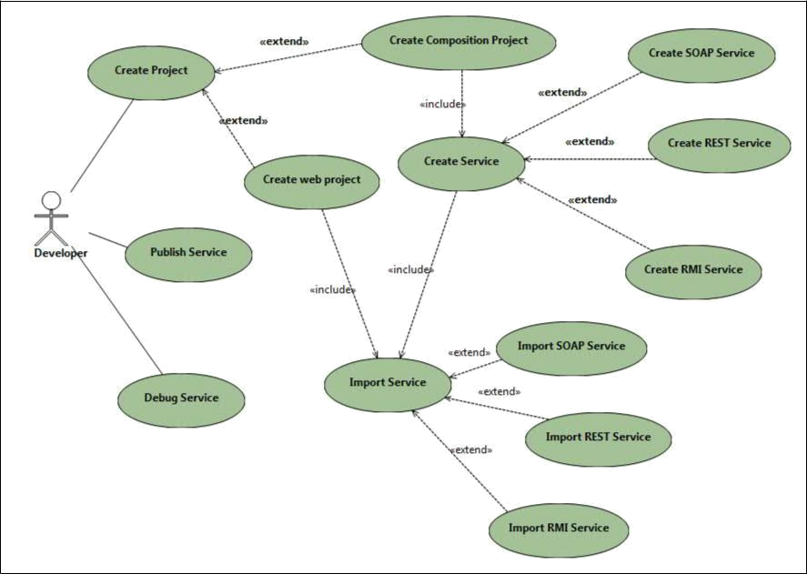

Figure 6.1: Use case diagram

6.3 DATA MODEL AND DESCRIPTION

6.3.1 Data Description

Data objects that will be managed/manipulated by the software are described in this section. The database entities or files or data structures required to be described. For data objects details can be given as below

6.3.2 Data objects and Relationships

Data objects and their major attributes and relationships among data objects are de-scribed using an ERD- like form.

6.4 FUNCTIONAL MODEL AND DESCRIPTION

A description of each major software function, along with data flow (structured anal-ysis) or class hierarchy (Analysis Class diagram with class description for object oriented system) is presented.

AIT, Department of Computer Engineering 2017-2018 I
19

6.4.1 Data Flow Diagram

6.4.1.1 Level 0 Data Flow Diagram

6.4.1.2 Level 1 Data Flow Diagram

6.4.2 Description of functions

A description of each software function is presented. A processing narrative for function n is presented.(Steps)/ Activity Diagrams. For Example Refer 6.2
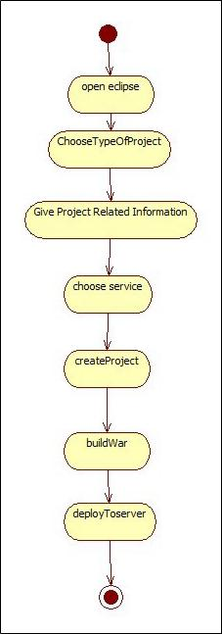

Figure 6.2: Activity diagram

AIT, Department of Computer Engineering 2017-2018 I
20

6.4.3 Activity Diagram:

The Activity diagram represents the steps taken.

6.4.4 Non Functional Requirements:

Interface Requirements

Performance Requirements

Software quality attributes such as availability [ related to Reliability], modi-fiability [includes portability, reusability, scalability] , performance, security, testability and usability[includes self adaptability and user adaptability]

6.4.5 State Diagram:

State Transition Diagram

Fig.6.3 example shows the state transition diagram of Cloud SDK. The states are represented in ovals and state of system gets changed when certain events occur. The transitions from one state to the other are represented by arrows. The Figure shows important states and events that occur while creating new project.

6.4.6 Design Constraints

Any design constraints that will impact the subsystem are noted.

6.4.7 Software Interface Description

The software interface(s)to the outside world is(are) described. The requirements for interfaces to other devices/systems/networks/human are stated.

AIT, Department of Computer Engineering 2017-2018 I
21

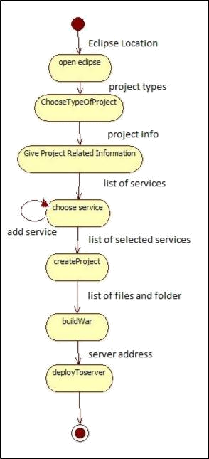

Figure 6.3: State transition diagram

AIT, Department of Computer Engineering 2017-2018 I
22

CHAPTER 7

DETAILED DESIGN DOCUMENT USING

APPENDIX A AND B

7.1 INTRODUCTION

This document specifies the design that is used to solve the problem of Product.

7.2 ARCHITECTURAL DESIGN

A description of the program architecture is presented. Subsystem design or Block diagram,Package Diagram,Deployment diagram with description is to be presented.
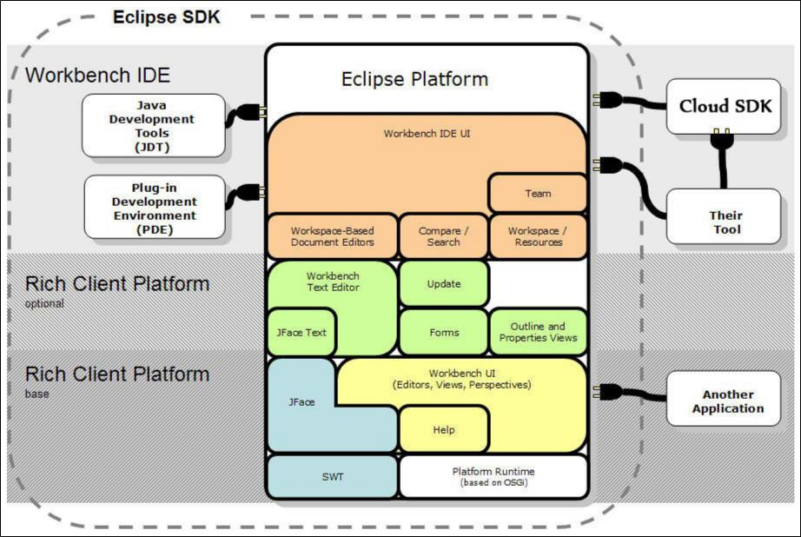

Figure 7.1: Architecture diagram

7.3 DATA DESIGN (USING APPENDICES A AND B)

A description of all data structures including internal, global, and temporary data structures, database design (tables), file formats.

7.3.1 Internal software data structure

Data structures that are passed among components the software are described.

AIT, Department of Computer Engineering 2017-2018 I
24

7.3.2 Global data structure

Data structured that are available to major portions of the architecture are described.

7.3.3 Temporary data structure

Files created for interim use are described.

7.3.4 Database description

Database(s) / Files created/used as part of the application is(are) described.

7.4 COMPOENT DESIGN

Class diagrams, Interaction Diagrams, Algorithms. Description of each component description required.

7.4.1 Class Diagram

AIT, Department of Computer Engineering 2017-2018 I
25

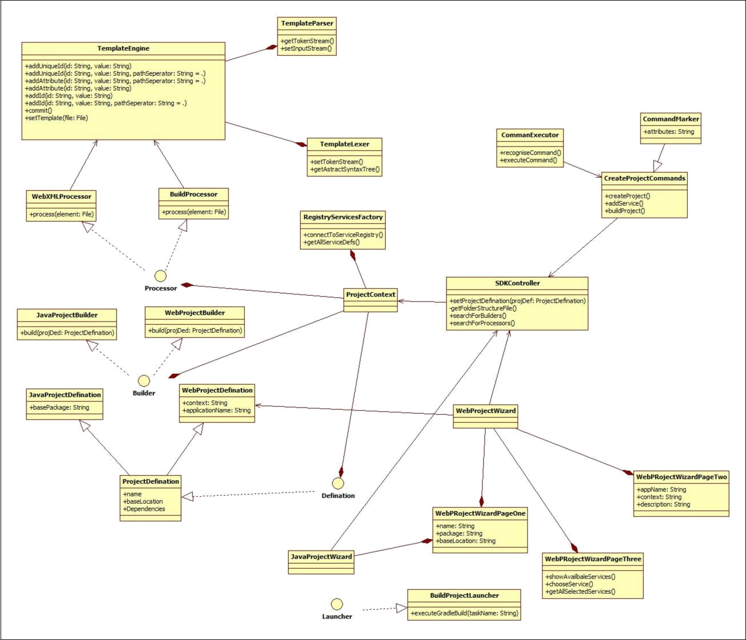

Figure 7.2: Class Diagram

AIT, Department of Computer Engineering 2017-2018 I
26

CHAPTER 8

SUMMARY AND CONCLUSION

Write one page summary and conclusion

AIT, Department of Computer Engineering 2017-2018 I
28

CHAPTER 9

REFERENCES

- R. S. Pressman, Software Engineering (3rd Ed.): A Practitioner’s Approach.

New York, NY, USA: McGraw-Hill, Inc., 1992.

- P. Kulkarni, Knowledge Innovation Strategy. Pune: Bloomsbury Publication, 2015.

- P. Sinha, Electronic Health Record. IEEE Press Wiley.

- McKinsey, “Big data: The next frontier for innovation, competition, and pro-ductivity,” tech. rep.

- “Digital competition:http://www.mckinsey.com/insights.”

- “Government website to support entrepre-naurs:http://msme.gov.in/mob/home.aspx.”

AIT, Department of Computer Engineering 2017-2018 I
30

ANNEXURE A

LABORATORY ASSIGNMENTS ON

PROJECT ANALYSIS OF ALGORITHMIC

DESIGN

To develop the problem under consideration and justify feasibilty using con-cepts of knowledge canvas and IDEA Matrix.

Refer [2] for IDEA Matrix and Knowledge canvas model. Case studies are given in this book. IDEA Matrix is represented in the following form. Knowl-edge canvas represents about identification of opportunity for product. Feasi-bility is represented w.r.t. business perspective.

I | D | E | A
Increase | Drive | Educate | Accelerate
Improve | Deliver | Evaluate | Associate
Ignore | Decrease | Eliminate | Avoid

Table A.1: IDEA Matrix

Project problem statement feasibility assessment using NP-Hard, NP-Complete or satisfy ability issues using modern algebra and/or relevant mathematical models.

input x,output y, y=f(x)

AIT, Department of Computer Engineering 2017-2018 I
32

ANNEXURE B

LABORATORY ASSIGNMENTS ON

PROJECT QUALITY AND RELIABILITY

TESTING OF PROJECT DESIGN

It should include assignments such as

Use of divide and conquer strategies to exploit distributed/parallel/concurrent processing of the above to identify object, morphisms, overloading in func-tions (if any), and functional relations and any other dependencies (as per re-quirements). It can include Venn diagram, state diagram, function relations, i/o relations; use this to derive objects, morphism, overloading

Use of above to draw functional dependency graphs and relevant Software modeling methods, techniques including UML diagrams or other necessities using appropriate tools.

Testing of project problem statement using generated test data (using mathe-matical models, GUI, Function testing principles, if any) selection and appro-priate use of testing tools, testing of UML diagram’s reliability. Write also test cases [Black box testing] for each identified functions. You can use Mathe-matica or equivalent open source tool for generating test data.

Additional assignments by the guide. If project type as Entreprenaur, Refer [3],[4],[5], [6]

AIT, Department of Computer Engineering 2017-2018 I
34

ANNEXURE C

PROJECT PLANNER

Using planner or alike project management tool.

AIT, Department of Computer Engineering 2017-2018 I
36

ANNEXURE D

REVIEWERS COMMENTS OF PAPER

SUBMITTED

(At-least one technical paper must be submitted in Term-I on the project design in the conferences/workshops in IITs, Central Universities or UoP Conferences or equivalent International Conferences Sponsored by IEEE/ACM)

- Paper Title:

- Name of the Conference/Journal where paper submitted :

- Paper accepted/rejected :

- Review comments by reviewer :

- Corrective actions if any :

AIT, Department of Computer Engineering 2017-2018 I
38

ANNEXURE E

PLAGIARISM REPORT

Plagiarism report

AIT, Department of Computer Engineering 2017-2018 I
40

